A convenient green synthetic approach to a novel class of aryldifluoromethyl pyrimidine derivatives containing strobilurin motif as insecticidal agents

Shulin Hao, Zengfei Cai, Wenliang Zhang, Yangyang Cao and Xiaohua Du*

Zhejiang University of Technology, Catalytic Hydrogenation Research Center, Zhejiang Key Laboratory of Green Pesticides and Cleaner Production Technology, Zhejiang Green Pesticide Collaborative Innovation Center, Hangzhou 310014, PR China
*Corresponding author.
E-mail addresses: duxiaohua@zjut.edu.cn
Supporting Information

Table of Contents |  | Page
1 | Chemical appearance and yield of intermediates 2, 3, 4 | 2
2 | Data of intermediates and target compounds | 3
3 | ¹H, ¹³C and ¹⁹F NMR spectra for some intermediates and target compounds | 6

- Chemical appearance and yield of intermediates 2, 3, 4

Table 1. Chemical appearance and yield of intermediate 2a-2e
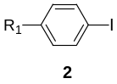
intermediate | R₁ | appearance | yield /%
2a | H | Brown solid | 79
2b | CF₃ | Brown solid | 81
2c | F | Brown solid | 77
2d | Cl | Brown solid | 78
2e | CH₃O | Brown solid | 76

Table 2. Chemical appearance and yield of intermediate 3a-3e
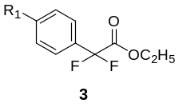
intermediate | R₁ | appearance | yield /%
3a | H | Light yellow oil | 73
3b | CF₃ | Light yellow oil | 79
3c | F | Light yellow oil | 74
3d | Cl | Light yellow oil | 79
3e | CH₃O | Light yellow oil | 67

Table 3. Chemical appearance and yield of intermediate 4a-4e

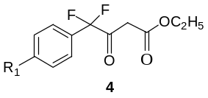
intermediate | R₁ | appearance | yield /%
4a | H | Light yellow oil | 81
4b | CF₃ | Light yellow oil | 78
4c | F | Light yellow oil | 81
4d | Cl | Light yellow oil | 82
4e | CH₃O | Light yellow oil | 78

2. Data of intermediates and target compounds:
2.1 Characterization of intermediates:
ethyl 4,4-difluoro-3-oxo-4-(4-(trifluoromethyl)phenyl)butanoate (4b)
¹H NMR (400 MHz, CDCl₃) δ: 12.00 (bs, 0.5H), 7.69-7.76 (m, 4H), 5.66 (s, 0.5H), 4.15-4.29 (q, J = 7.2 Hz, 2H), 3.75 (br, s, 2*0.5H), 1.22-1.34 (t, J = 7.2 Hz, 3H).
4-(4-chlorophenyl)-4,4-difluoro-3-oxobutanoate(4d)
¹H NMR (400 MHz, CDCl₃) δ: 15.30 (bs, 0.5H), 7.40-7.52 (m, 4H), 5.68(s,0.5H), 4.15-4.28 (2q, J = 7.2 Hz, 2H), 3.75 (br s, 2x0.5H), 1.22-1.35 (t, J = 7.2 Hz, 3 H).
6-(difluoro(phenyl)methyl)pyrimidin-4-ol (5a)
m.p. 172-174 ℃, ¹H NMR (400 MHz, DMSO-d₆) δ: 12.90 (s, 1H), 7.49-7.59 (m, 5H), 6.74 (s, 1H). ¹³C NMR (100 MHz, DMSO-d₆) δ: 160.9, 159.2 (t, J = 30 Hz), 151.3, 134.6 (t, J = 27 Hz), 130.6, 128.6, 125.5 (t, J = 6 Hz), 117.6 (t, J = 242 Hz), 111.7 (t, J = 5 Hz). ¹⁹F NMR (376 MHz, DMSO-d₆) δ -98.6. HRMS(M+H)⁺, C₁₁H₉F₂N₂O, calculated: 223.0677, found: 223.0678.
6-(difluoro(phenyl)methyl)-2-methylpyrimidin-4-ol (5b)
m.p. 180-182 ℃, ¹H NMR (400 MHz, DMSO-d₆) δ: 12.78 (s, 1H), 7.49-7.59 (m, 5H), 6.57 (s, 1H), 2.27 (s, 3H). ¹³C NMR (100 MHz, DMSO-d₆) δ: 160.9, 159.2 (t, J = 30 Hz), 151.3, 134.6 (t, J = 27 Hz), 130.6, 128.6, 125.5 (t, J = 6 Hz), 117.6 (t, J = 242 Hz), 111.7 (t, J = 5 Hz). ¹⁹F NMR (376 MHz, DMSO-d₆) δ: -98.2. HRMS(M+H)⁺, C₁₂H₁₁F₂N₂O, calculated: 237.0834, found: 237.0834.
6-(difluoro(4-(trifluoromethyl)phenyl)methyl)pyrimidin-4-ol (5c)
m.p. 193-195℃, ¹H NMR (400 MHz, DMSO-d₆) δ: 12.90 (s, 1H), 8.24 (s, 1H),7.89 (d, J = 8.0 Hz, 2H), 7.83 (d, J = 8.0 Hz, 2H), 6.80 (s, 1H). ¹³C NMR (100 MHz, DMSO-d₆) δ: 161.0, 158.3 (t, J = 30 Hz), 151.7, 138.6 (t, J =28 Hz), 130.9 (q, J = 33 Hz), 126.7 (t, J = 6 Hz), 125.7 (q, J = 4 Hz), 123.7 (q, J = 271 Hz), 117.0 (t, J = 243 Hz), 111.9 (t, J = 5 Hz). ¹⁹F NMR (376 MHz, DMSO-d₆) δ: -61.5, -99.6. HRMS(M+H)⁺, C₁₂H₈F₅N₂O, calculated: 291.0551, found: 291.0551.
6-(difluoro(4-(trifluoromethyl)phenyl)methyl)-2-methylpyrimidin-4-ol (5d)
m.p. 218-220 ℃, ¹H NMR (400 MHz, DMSO-d₆) δ: 12.78 (s, 1H), 7.89 (d, J = 8.0 Hz, 2H), 7.83 (d, J = 8.0 Hz, 2H), 6.62(s, 1H), 2.25(s, 3H); ¹³C NMR (100 MHz, DMSO-d₆) δ: 162.0, 161.2, 158.3 (t, J = 30 Hz), 138.7 (t, J = 26 Hz), 130.9 (q, J = 32 Hz), 126.7 (t, J = 25 Hz), 125.7 (q, J = 4 Hz), 123.7 (q, J = 271 Hz), 117.0 (t, J = 242 Hz), 109.0 (s). 21.6. ¹⁹F NMR (376 MHz, DMSO-d₆) δ: -61.5, -99.2. HRMS(M+H)⁺, C₁₃H₁₀F₅N₂O, calculated: 305.0708, found: 305.0708.
6-(difluoro(4-fluorophenyl)methyl)pyrimidin-4-ol (5e)
m.p. 205-207 ℃, ¹H NMR (400 MHz, DMSO-d₆) δ:12.87 (s, 1H), 8.23 (s, 1H),7.35 (m, 2H), 7.34 (t, 2H), 6.73 (s, 1H). ¹³C NMR (100 MHz, DMSO-d₆) δ: 163.2 (d, J = 246 Hz), 160.9, 158.8 (t, J = 30 Hz), 151.4, 130.67-131.2 (m), 128.1-128.3 (m), 117.8 (t, J = 242 Hz), 115.6 (d, J = 22 Hz), 111.8 (t, J = 5 Hz). ¹⁹F NMR (376 MHz, DMSO-d₆) δ: -97.6, -110.2. HRMS(M+Na)⁺, C₁₁H₇F₃N₂NaO , calculated: 263.0403, found: 263.0403.
6-(difluoro(4-fluorophenyl)methyl)-2-methylpyrimidin-4-ol (5f)
m.p. 230-233 ℃, ¹H NMR (400 MHz, DMSO-d₆) δ: 12.75 (s, 1H), 7.62-7.66 (m, 2H), 7.33 (t, 2H), 6.56 (s, 1H), 2.26 (s, 3H), ¹³C NMR (100 MHz, DMSO-d₆) δ: 163.2 (d, J = 246 Hz), 162.0 (s), 161.0 (s), 158.8 (t, J = 30 Hz), 130.8-131.4 (m), 128.1-128.3 (m), 117.3 (t, J = 243 Hz), 115.6 (d, J = 22 Hz), 108.8, 21.8. ¹⁹F NMR (376 MHz, DMSO-d₆) δ: -97.14, -110.29. HRMS(M+H)⁺, C₁₂H₁₀F₃N₂O, calculated: 255.0740, found: 255.0740.
6-((4-chlorophenyl)difluoromethyl)pyrimidin-4-ol (5g)
m.p. 202-204 ℃, ¹H NMR (400 MHz, DMSO-d₆) δ: 12.79 (s, 1H), 8.23 (s, 1H),7.61 (d, J = 8.0 Hz, 2H), 7.57 (d, J = 8.0 Hz, 2H), 6.74(s, 1H). ¹³C NMR (100 MHz, DMSO-d₆) δ: 160.89, 158.62(t, J = 32 Hz), 151.45, 135.50, 133.47 (t, J = 26 Hz), 128.74, 127.62, 117.22(t, J = 242 Hz), 111.8. ¹⁹F NMR (376 MHz, DMSO-d₆) δ: -98.63(s). HRMS(M+Na)⁺, C₁₁H₇ClF₂N₂NaO, calculated: 279.0107, found: 279.0107.
6-((4-chlorophenyl)difluoromethyl)-2-methylpyrimidin-4-ol (5h)
m.p. 230-233 ℃, ¹H NMR (400 MHz, DMSO-d₆) δ: 12.75 (s, 1H), 7.61 (d, J = 12.0 Hz, 2H), 7.57 (d, J = 8.0 Hz, 2H), 6.57 (s, 1H), 2.26 (s, 3H). ¹³C NMR (100 MHz, DMSO-d₆) δ: 162.0, 161.1, 158.7 (t, J = 30 Hz), 135.5, 133.6 (t, J = 28 Hz), 128.7, 127.60 (t, J = 5 Hz), 117.23 (t, J = 243 Hz), 108.78. 21.22. ¹⁹F NMR (376 MHz, DMSO-d₆) δ: -98.2. HRMS(M+H)⁺, C1₂H₁₀ClF₂N₂O, calculated: 271.0444, found: 271.0444.
6-((4-chlorophenyl)difluoromethyl)-2-mercaptopyrimidin-4-ol (5i)
m.p. 223-225 ℃, ¹H NMR (400 MHz, DMSO-d₆) δ: 12.98 (s, 1H), 12.71 (s, 1H), 7.74 (d, J = 8.0 Hz, 2H), 7.64 (d, J = 8.0 Hz, 2H), 6.21(s, 1H). ¹³C NMR (100 MHz, DMSO-d₆) δ: 177.2, 160.7, 148.2 (t, J = 30 Hz), 136.9, 132.0 (t, J = 28 Hz), 129.5, 128.50, 116.1 (t, J =245 Hz), 104.4 (t, J = 6 Hz). ¹⁹F NMR (376 MHz, DMSO-d₆) δ: -95.7. HRMS(M+H)⁺, C₁₁H₈ClF₂N₂OS, calculated: 289.0008, found: 289.0008.
2.2 Characterization of the target products:
(E)-methyl 2-(2-((6-(difluoro(phenyl)methyl)pyrimidin-4-yloxy)methyl)phenyl)-3-methoxyacrylate (7a)
¹H NMR (400 MHz, DMSO-d₆) δ 8.24 (s, 1H), 7.61-7.55 (m, 4H), 7.49 (d, J = 6.5 Hz, 3H), 7.30 (d, J = 4.0 Hz, 3H), 7.06 (dd, J = 5.7, 2.9 Hz, 1H), 6.78 (s, 1H), 4.92 (s, 2H), 3.70 (s, 3H), 3.43 (s, 3H). ¹³C NMR (100 MHz, DMSO-d₆) δ: 166.6, 162.3, 161.2, 159.9, 158.0 (t, J = 31.1 Hz), 153.2, 134.2, 132.8 (s), 131.5, 130.6, 129.7, 128.6, 127.9, 127.7, 125.6 (t, J = 5.9 Hz), 117.5 (t, J = 243.7 Hz), 110.6 (t, J = 4.6 Hz), 108.4, 61.71, 51.0, 47.4, 35.7, 30.7. HRMS(M+H)⁺, C₂₃H₂₁F₂N₂O₄ , calculated: 427.1464, found: 427.1464.
(E)-methyl 2-(2-((6-(difluoro(phenyl)methyl)-2-methylpyrimidin-4-yloxy)methyl)phenyl)-3-methoxyacrylate (7b)
¹H NMR (400 MHz, DMSO-d₆) δ: 7.62 (s, 1H), 7.58 (d, J = 5.7 Hz, 2H), 7.50 (s, 4H), 7.33 (dd, J = 5.4, 3.4 Hz, 2H), 7.15-7.08 (m, 1H), 7.02 (s, 1H), 5.31 (s, 2H), 3.78 (s, 3H), 3.55 (s, 3H), 2.51 (s, 3H). ¹³C NMR (100 MHz, DMSO-d₆) δ: 169.5, 168.1, 166.9, 160.7, 134.9, 132.7, 131.1, 130.6, 128.7, 128.7, 127.9, 127.5, 125. 5 (t, J = 5.8 Hz), 108.8, 101.3 (t, J = 4.9 Hz), 66.1, 61.7, 51.1, 25.6. HRMS(M+H)⁺, C₂₄H₂₃F₂N₂O₄, calculated: 441.1620, found: 441.1620.
(E)-methyl 2-(2-((6-(difluoro(4-fluorophenyl)methyl)pyrimidin-4-yloxy)methyl)phenyl)-3-methoxyacrylate(7c)
¹H NMR (500 MHz, DMSO-d₆) δ: 8.26 (s, 1H), 7.66 (dd, J = 8.7, 5.3 Hz, 1H), 7.59 (s, 1H), 7.38-7.24 (m, 5H), 7.10-6.97 (m, 1H), 6.79 (s, 1H), 4.92 (s, 2H), 3.72 (s, 3H), 3.45 (s, 3H). ¹³C NMR (125 MHz, DMSO-d₆) δ: 167.1, 164.7, 162.7, 161.7, 160.4, 158.1 (t, J = 31.1 Hz), 153.9, 134.7, 133.3, 132.0, 130.2, 128.8 (t, J = 4.5 Hz), 128.8-128.6 (m), 128.4, 128.2, 117.7, 116.3, 116.1, 111.1 (t, J = 4.5 Hz), 108.8, 62.2, 51.5, 48.0. ¹⁹F NMR (470 MHz, DMSO-d₆) δ: -97.6, -110.1 (d, J = 2.6 Hz). HRMS(M+H)⁺, C₂₃H₂₀F₃N₂O₄, calculated: 445.1370, found: 445.1370.
(E)-methyl 2-(2-((6-(difluoro(4-fluorophenyl)methyl)-2-methylpyrimidin-4-yloxy)methyl)phenyl)-3-methoxyacrylate(7d)
¹H NMR (400 MHz, DMSO-d₆) δ: 7.69-7.56 (m, 3H), 7.55-7.45 (m, 1H), 7.35-7.27 (m, 4H), 7.17-7.06 (m, 1H), 7.04 (s, 1H), 5.32 (s, 2H), 3.79 (s, 3H), 3.56 (s, 3H), 2.51 (s, 3H). ¹³C NMR (100 MHz, DMSO-d₆) δ: 169.5, 168.2, 166.8, 162.6 (t, J = 31.0 Hz), 163.2, 160.7, 134.9, 132.7, 131.1, 128.7, 128.2 (t, J = 4.4 Hz), 128.1 (t, J = 4.5 Hz), 127.9, 127.5, 117.3, 115.9, 115.6, 108.8, 101.3, 66.1, 61.7, 51.1, 25.5. HRMS(M+H)⁺, C₂₄H₂₂F₃N₂O₄, calculated: 459.1526, found: 459.1526.
(E)-methyl 2-(2-((6-(difluoro(4-(trifluoromethyl)phenyl) methyl)pyrimidin-4-yloxy)methyl)phenyl)-3-methoxyacrylate (7e)
¹H NMR (500 MHz, DMSO-d₆) δ: 8.27 (s, 1H), 7.90 (d, J = 8.4 Hz, 2H), 7.85 (d, J = 8.4 Hz, 2H), 7.59 (s, 1H), 7.33-7.28 (m, 3H), 7.15-7.00 (m, 1H), 6.86 (s, 1H), 4.92 (s, 2H), 3.72 (s, 3H), 3.43 (s, 3H). ¹³C NMR (125 MHz, DMSO-d₆) δ: 167.1, 161.7, 160.3, 157.6 (t, J = 30.6 Hz), 154.0, 138.9 (t, J = 27.1 Hz), 134.6, 133.2, 131.9, 130.2, 128.5, 128.2, 127.3 (t, J = 5.7 Hz), 126.2 (q, J = 3.6 Hz), 125.3, 123.10, 117.4 (t, J = 244.6 Hz), 111.4 (t, J = 4.3 Hz), 108.8, 62.2, 51.5, 48.0, 40.14 (m). ¹⁹F NMR (470 MHz, DMSO-d₆) δ: -61.5, -99.6. HRMS(M+H)⁺, C₂₄H₂₀F₅N₂O₄, calculated: 495.1338, found: 495.1338.
(E)-methyl 2-(2-((6-(difluoro(4-methoxyphenyl)methyl) pyrimidin-4-yloxy)methyl)phenyl)-3-methoxyacrylate(7f)
¹H NMR (500 MHz, DMSO-d₆) δ: 7.88 (d, J = 8.9 Hz, 2H), 7.66 (s, 1H), 7.51-7.46 (m, 1H), 7.37-7.33 (m, 3H), 7.15-7.11 (m, 1H), 7.05 (d, J = 8.9 Hz, 2H), 5.12 (d, J = 12.3 Hz, 2H), 3.83 (s, 3H), 3.78 (s, 3H), 3.54 (s, 3H). ¹³C NMR (125 MHz, DMSO-d₆) δ: 167.4, 165.5, 163.7, 161.1, 135.5, 133.3, 131.8, 131.7, 129.2, 128.4, 128.1, 122.1, 114.5, 109.3, 64.8, 62.3, 56.0, 51.7. HRMS(M+H)⁺, C₂₄H₂₃F₂N₂O₅, calculated: 457.1570, found: 457.1570.
(E)-methyl 2-(2-((6-((4-chlorophenyl)difluoromethyl)-2-methylpyrimidin-4-yloxy)methyl)phenyl)-3-methoxyacrylate(7g)
¹H NMR (400 MHz, DMSO-d₆) δ: 7.68-7.60 (m, 4H), 7.56 (m, 3H), 7.38-7.30 (m, 2H), 7.17 (d, J = 3.3 Hz, 1H), 7.08 (s, 1H), 5.36 (s, 2H), 3.80 (s, 3H), 3.59 (s, 3H). 2.26 (s, 3H). ¹³C NMR (100 MHz, DMSO-d₆) δ: 167.2, 162.6, 162.1, 161.9, 157.3 (t, J = 30.6 Hz), 136.1, 134.5, 133.9 (t, J = 27.6 Hz), 132.1, 132.0, 129.3, 128.6, 128.2 (t, J = 5.7 Hz), 127.6, 125.3, 117.6, 108.8 (t, J = 4.4 Hz), 108.5, 62.4, 51.8, 45.1, 22.9. HRMS(M+H)⁺, C₂₄H₂₂ClF₂N₂O₄, calculated: 475.1231, found: 475.1231.
(E)-methyl 2-(2-((6-(difluoro(phenyl)methyl)-2-methyl pyrimidin-4-yloxy)methyl)phenyl)-2-(methoxyimino) acetate(7h)
¹H NMR (500 MHz, DMSO-d₆) δ: 7.59 (dd, J = 7.7, 2.2 Hz, 3H), 7.53-7.40 (m, 5H), 7.25 (dd, J = 7.4, 1.3 Hz, 1H), 6.99 (s, 1H), 5.31 (s, 2H), 3.89 (s, 3H), 3.70 (s, 3H), 2.51 (s, 3H). ¹³C NMR (126 MHz, DMSO-d₆) δ: 169.6, 168.7, 163.4 (t, J = 31.1 Hz), 163.1, 149.3, 135.3 (t, J = 26.8 Hz), 134.4, 131.1, 130.8, 129.73 (s), 129.6, 129.2, 129.0, 128.7, 126.0 (t, J = 5.8 Hz), 118.1 (t, J = 243.6 Hz), 101. 8 (t, J = 4.6 Hz), 66.7, 63.8, 53.0, 26.0. HRMS(M+H)⁺, C₂₃H₂₂F₂N₃O₄, calculated: 442.1573, found: 442.1573.
(E)-methyl 2-(2-((6-(difluoro(4-fluorophenyl)methyl)-2-methylpyrimidin-4-yloxy)methyl)phenyl)-2-(methoxyimino)acetate (7i)
¹H NMR (400 MHz, DMSO-d₆) δ: 7.65 (dd, J = 8.8, 5.3 Hz, 1H), 7.61-7.56 (m, 1H), 7.51-7.39 (m, 1H), 7.34 (t, J = 8.8 Hz, 1H), 7.25 (dd, J = 7.3, 1.5 Hz, 1H), 7.00 (s, 1H), 5.31 (s, 1H), 3.90 (s, 1H), 3.71 (s, 1H), 2.51 (s, 2H). ¹³C NMR (100 MHz, DMSO-d₆) δ: 169.2, 168.2, 164.4, 162.6 (t, J = 31.3 Hz), 162.6, 162.0, 148.8, 133.9, 131.2 (t, J = 27.4 Hz), 130.3, 128.3-128.0 (m), 119.7, 117.3, 115.9, 115.7, 101.3 (t, J = 4.6 Hz), 66.2, 63.3, 52.5, 25.5. HRMS(M+H)⁺, C₂₃H₂₁F₃N₃O₄, calculated: 460.1479, found: 460.1479.
(E)-methyl 2-(2-((6-((4-chlorophenyl)difluoromethyl) pyrimidin-4-yloxy)methyl)phenyl)-2-(methoxyimino)acetate(7j)
¹H NMR (500 MHz, DMSO-d₆) δ: 8.27 (s, 1H), 7.66-7.51 (m, 5H), 7.34-7.26 (m, 2H), 7.10-7.02 (m, 1H), 6.81 (s, 1H), 4.92 (s, 2H), 3.73 (s, 3H), 3.45 (s, 3H). ¹³C NMR (125 MHz, DMSO-d₆) δ: 167.1, 161.7, 160.3, 157.9 (t, J = 30.9 Hz), 153.9, 136.1, 134.7, 133.8 (t, J = 27.5 Hz), 133.2, 132.0, 130.1, 129.3, 128.4, 128.2, 128.1, 128.1, 117.6 (t, J = 244.1 Hz), 111.2 (t, J = 4.3 Hz), 108.8, 62.3, 51.5, 48.0. HRMS(M+H)⁺, C₂₂H₁₉ClF₂N₃O₄, calculated: 462.1027, found: 462.1027.
(E)-methyl 2-(2-((6-((4-chlorophenyl)difluoromethyl)-2-methylpyrimidin-4-yloxy)methyl)phenyl)-2-(methoxyimino)acetate (7k)
¹H NMR (400 MHz, DMSO-d₆) δ: 7.59 (dd, J = 17.2, 8.2 Hz, 5H), 7.49-7.39 (m, 2H), 7.25 (d, J = 7.0 Hz, 1H), 7.01 (s, 1H), 5.31 (s, 2H), 3.90 (s, 3H), 3.71 (s, 3H), 2.50 (s, 3H). ¹³C NMR (100 MHz, DMSO-d₆) δ: 169.2, 168.2, 162.6, 148.8, 135.6, 133.9, 130.2, 129.2, 129.1, 128.9, 128.5, 128.2, 127.5 (t, J = 5.6 Hz), 101.3, 66.2, 63.3, 52.5, 25.5. HRMS(M+H)⁺, C₂₃H₂₁ClF₂N₃O₄, calculated: 476.1183, found: 476.1183.
(E)-methyl 2-(2-((6-(difluoro(4-methoxyphenyl)methyl) pyrimidin-4-yloxy)methyl)phenyl)-2-(methoxyimino) acetate (7l)
¹H NMR (500 MHz, DMSO-d₆) δ: 8.25 (s, 1H), 7.43-7.35 (m, 2H), 7.31 (d, J = 7.5 Hz, 1H), 7.19 (t, J = 7.3 Hz, 3H), 6.87 (d, J = 8.5 Hz, 2H), 6.14 (s, 1H), 4.84 (s, 2H), 3.85 (s, 3H), 3.72 (s, 3H), 3.71 (s, 2H), 3.70 (s, 3H). ¹³C NMR (125 MHz, DMSO-d₆) δ: 166.8, 162.9, 160.7, 158.4, 152.1, 149.1, 134.4, 130.7, 130.6, 130.0, 129.9, 129.3, 129.0, 128.2, 114.3, 112.0, 63.8, 55.5, 53.0, 47.0, 42.0. HRMS(M+H)⁺, C₂₃H₂₂F₂N₃O₅⁺ , calculated: 458.1522, found: 458.1522.

3. ¹H NMR, ¹³C NMR and ¹⁹F NMR spectra for intermediates and target compounds:

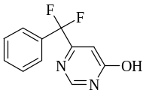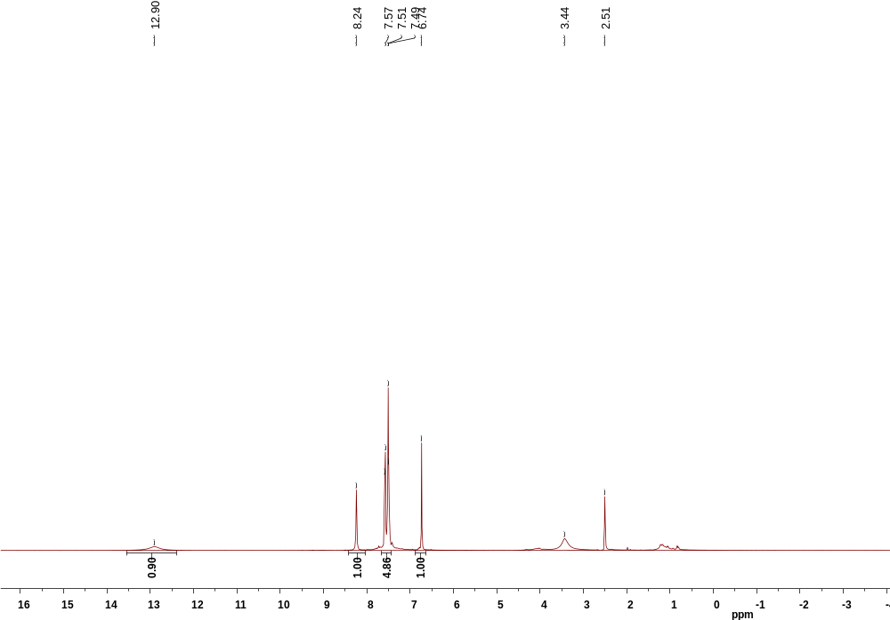
Fig. S01 ¹H NMR of compound 5a

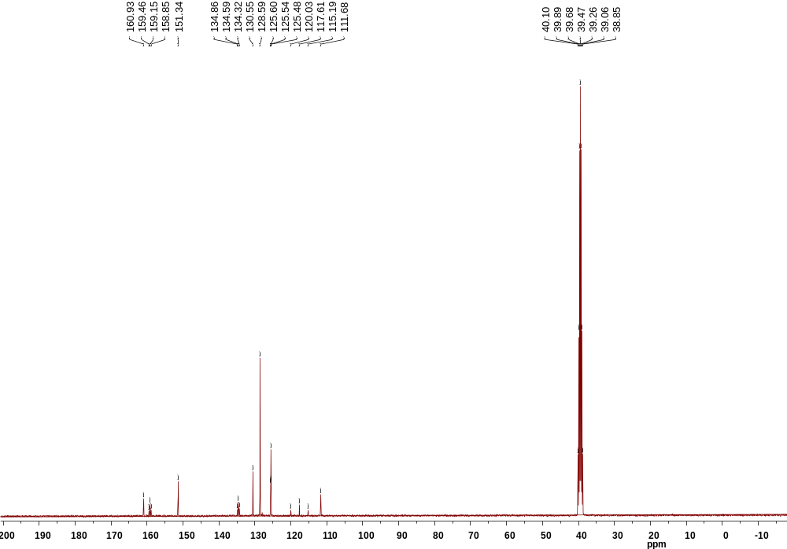
Fig. S02 ¹³C NMR of compound 5a

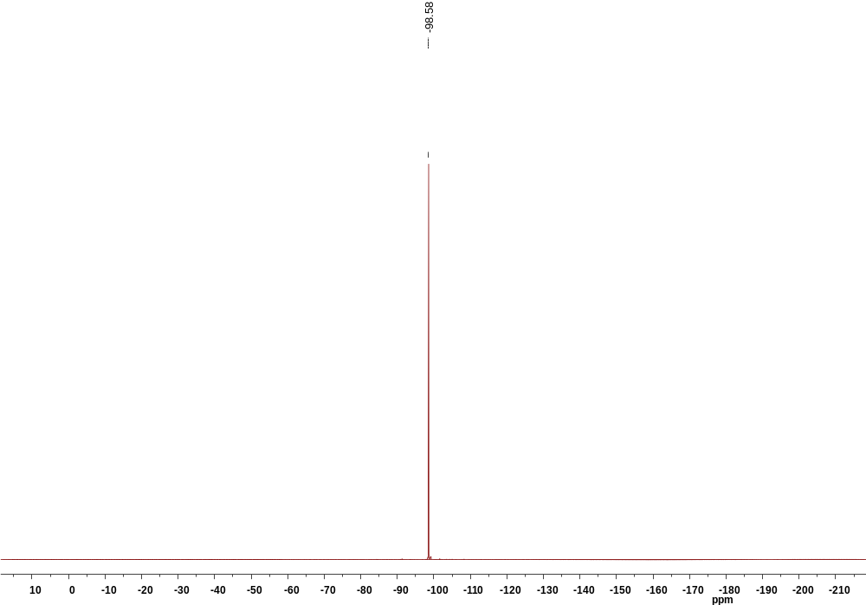
Fig. S03 ¹⁹F NMR of compound 5a

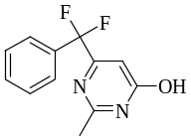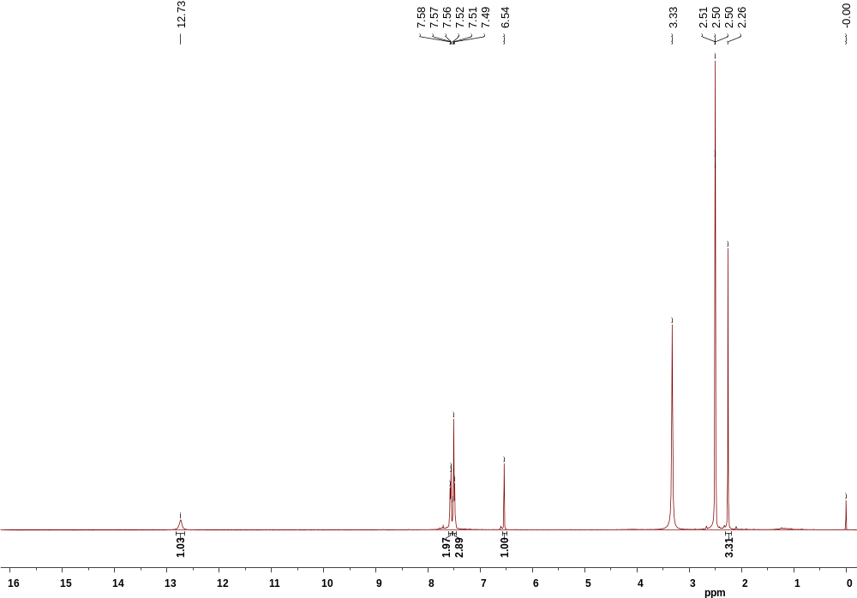
Fig. S04 ¹H NMR of compound 5b

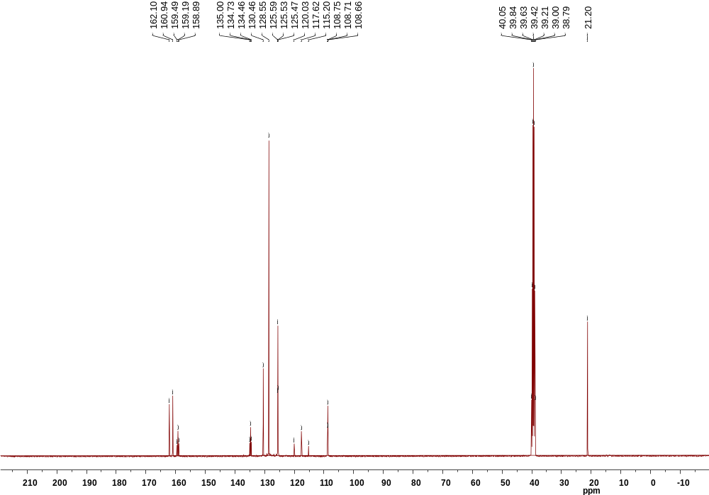
Fig. S05 ¹³C NMR of compound 5b

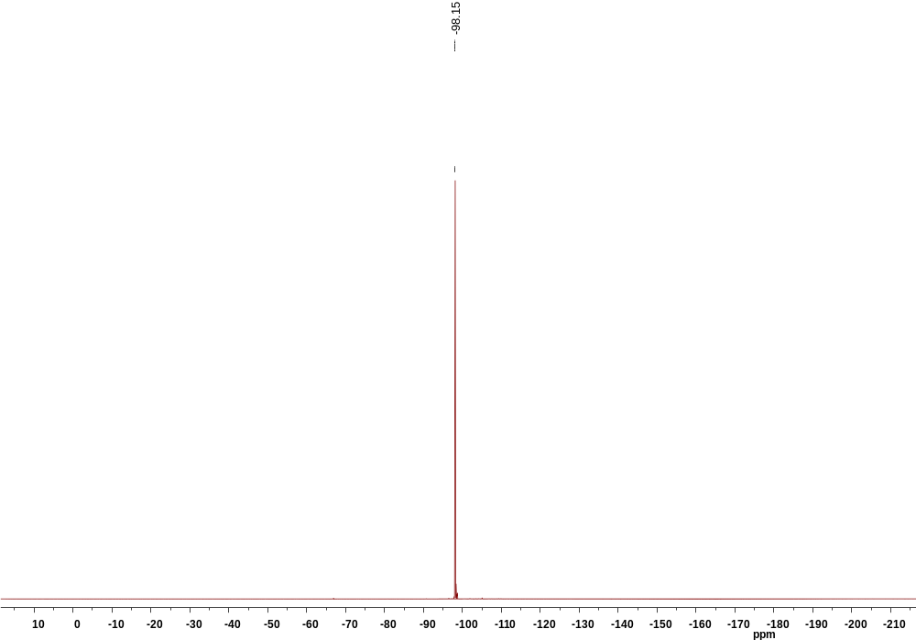
Fig. S06 ¹⁹F NMR of compound 5b

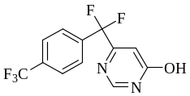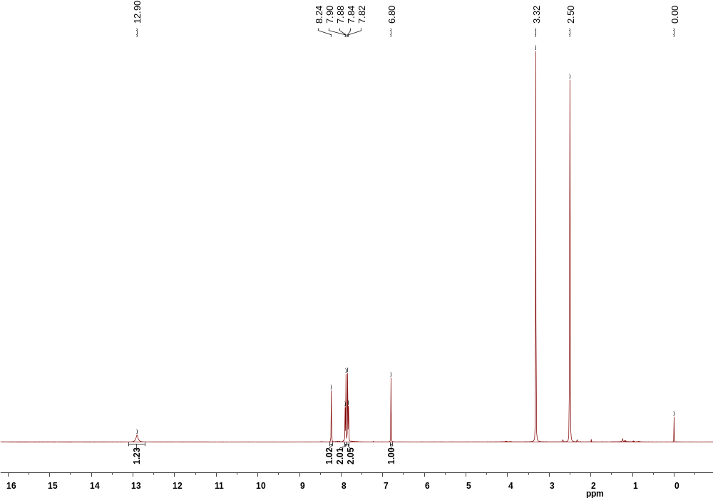
Fig. S07 ¹H NMR of compound 5c

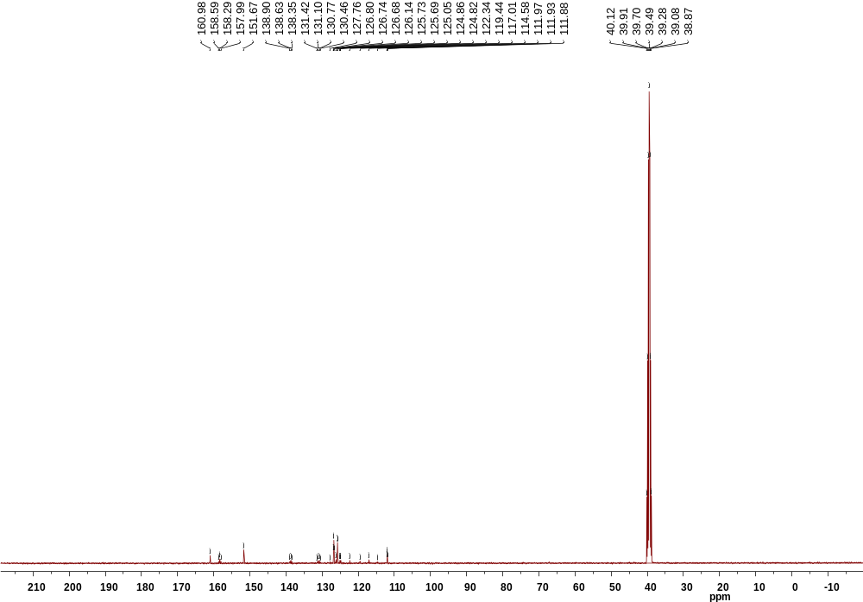
Fig. S08 ¹³C NMR of compound 5c

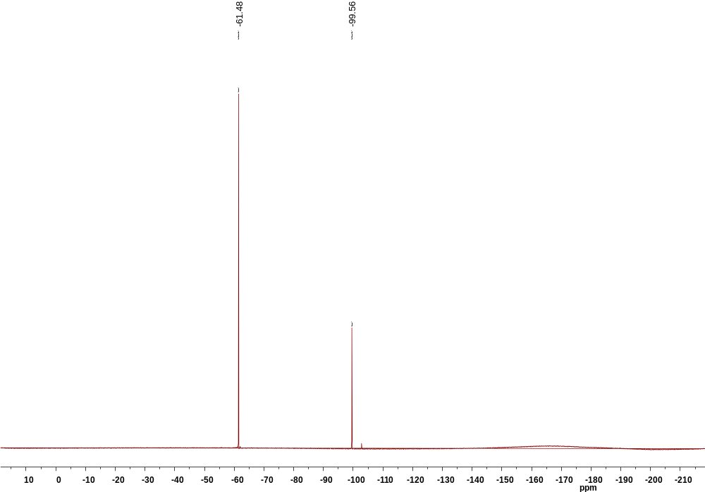
Fig. S09 ¹⁹F NMR of compound 5c

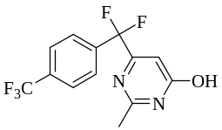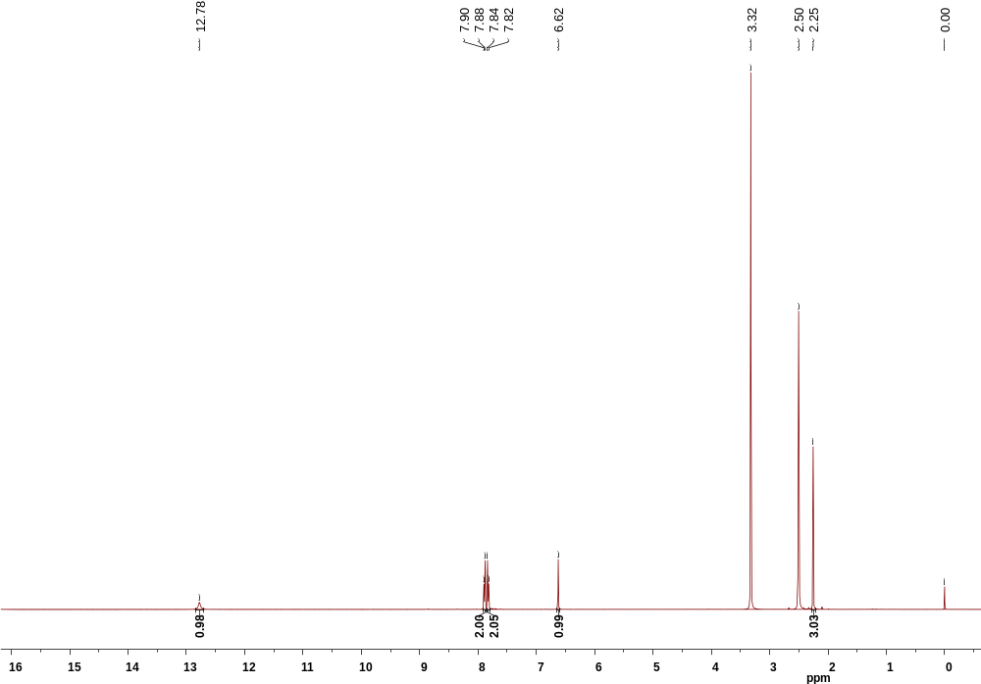
Fig. S10 ¹H NMR of compound 5d

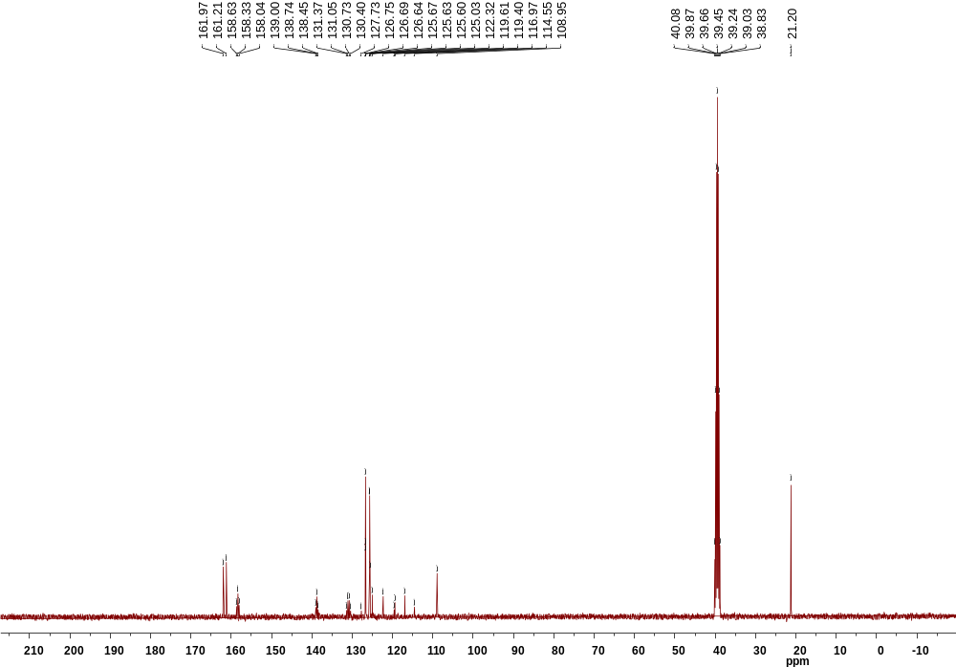
Fig. S11 ¹³C NMR of compound 5d

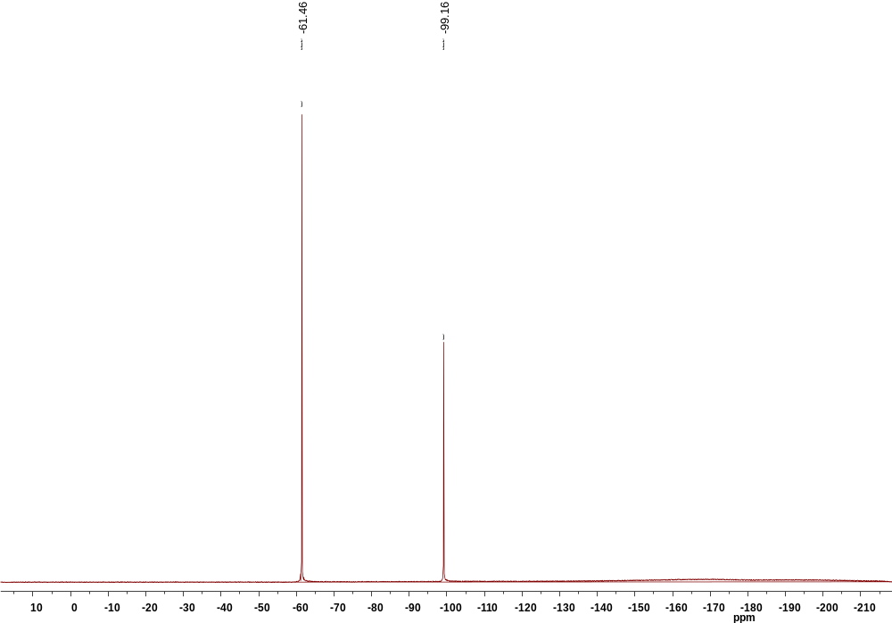
Fig. S12 ¹⁹F NMR of compound 5d

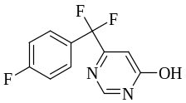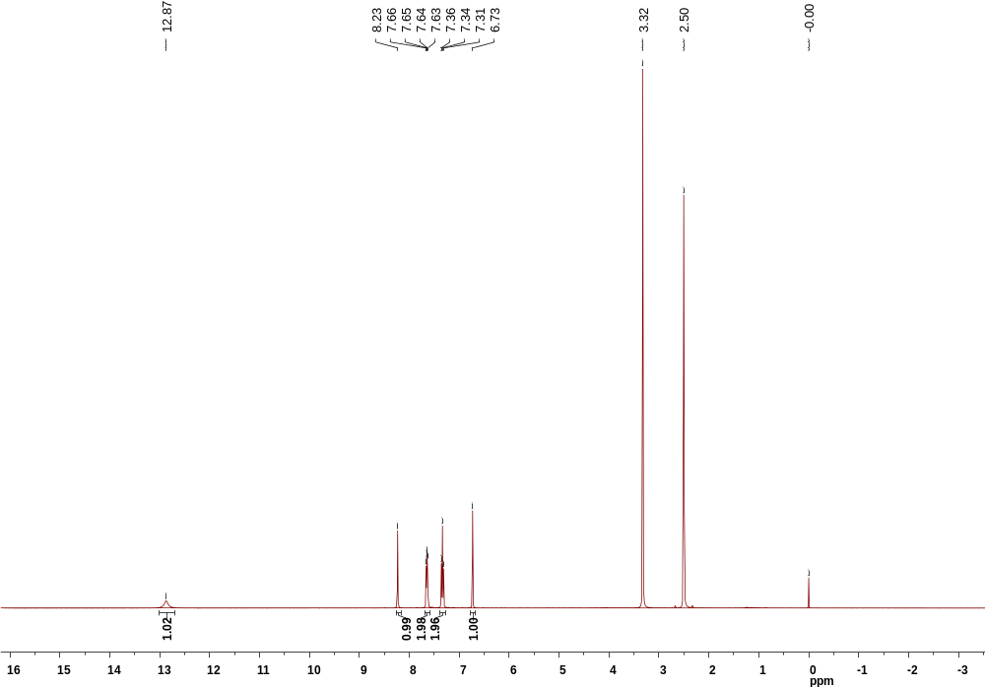
Fig. S13 ¹H NMR of compound 5e

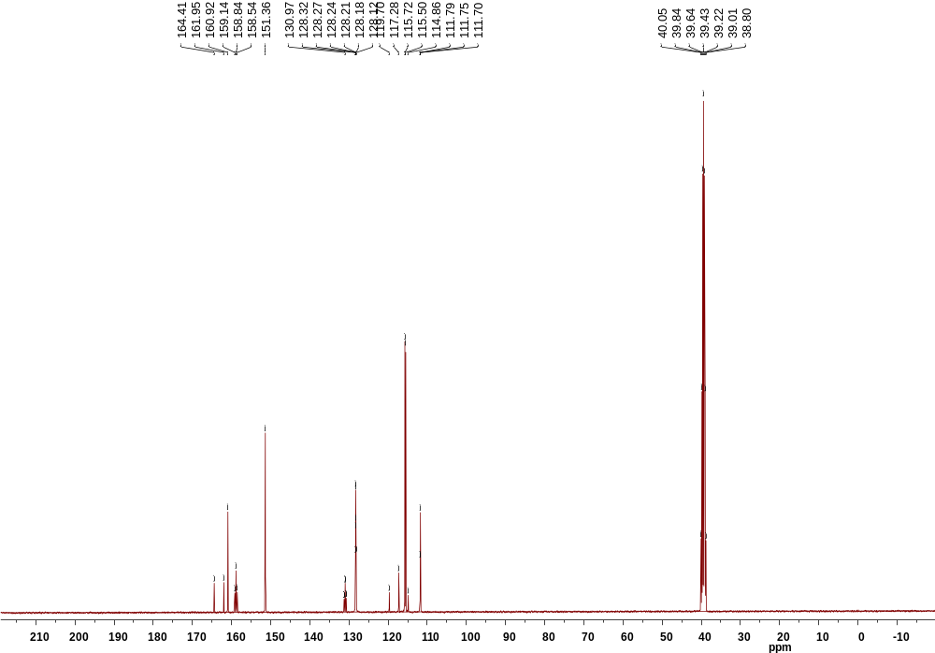
Fig. S14 ¹³C NMR of compound 5e

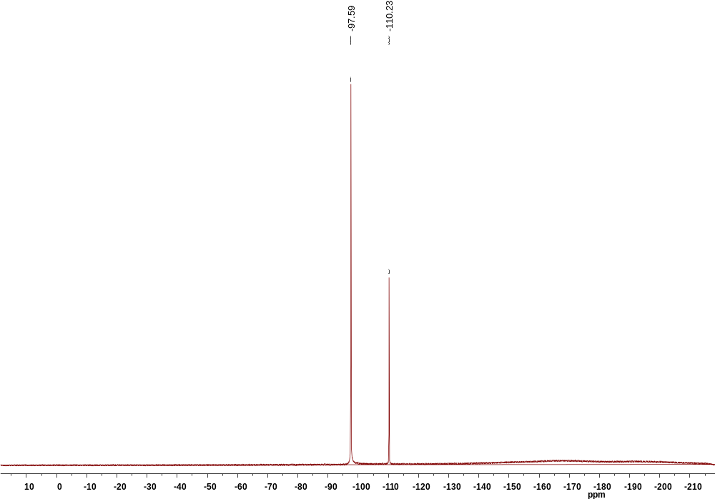
Fig. S15 ¹⁹F NMR of compound 5e

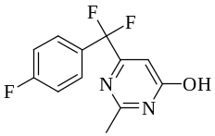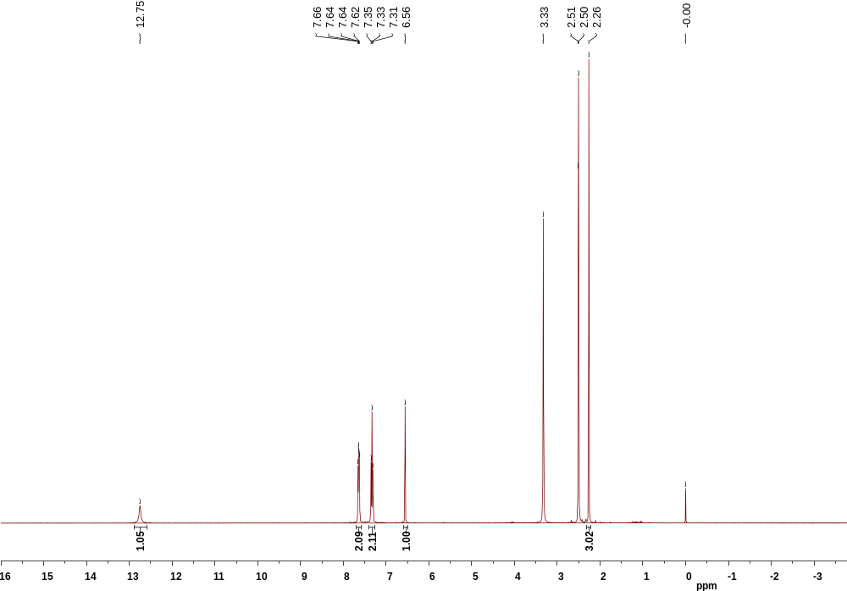
Fig. S16 ¹H NMR of compound 5f

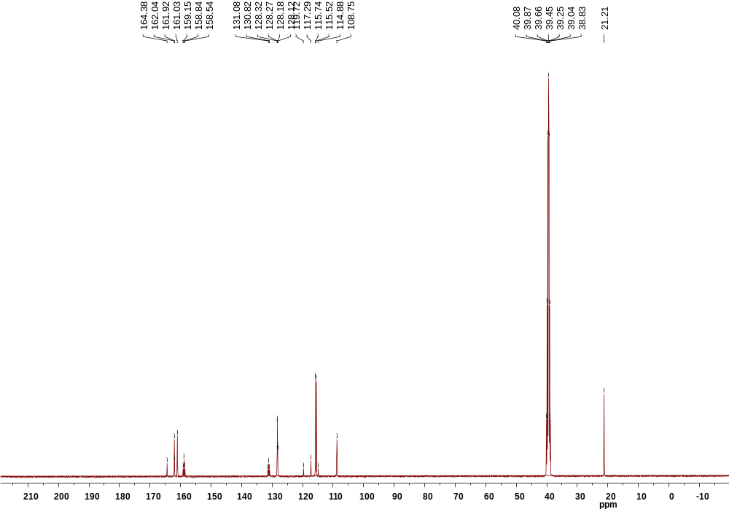
Fig. S17 ¹³C NMR of compound 5f

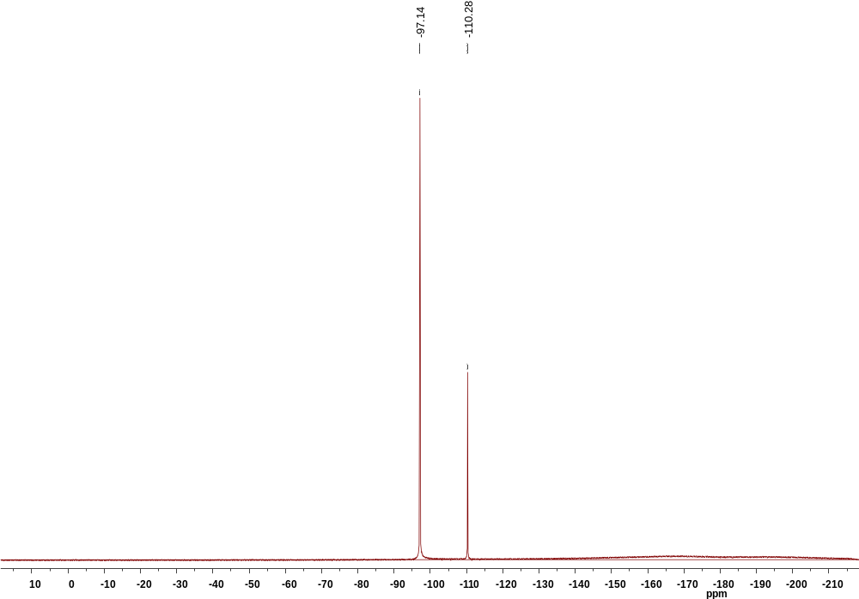
Fig. S18 ¹⁹F NMR of compound 5f

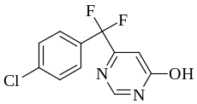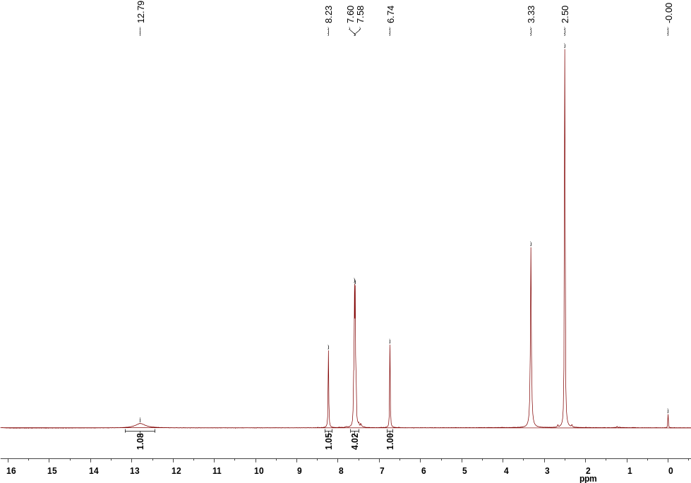
Fig. S19 ¹H NMR of compound 5g

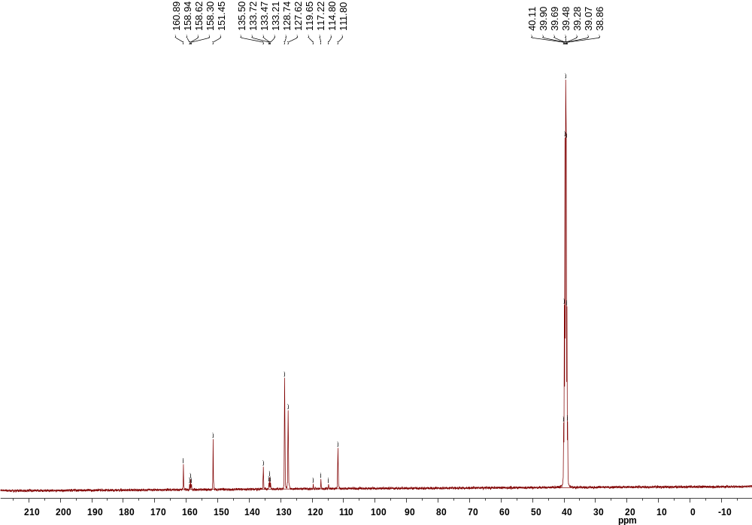
Fig. S20 ¹³C NMR of compound 5g

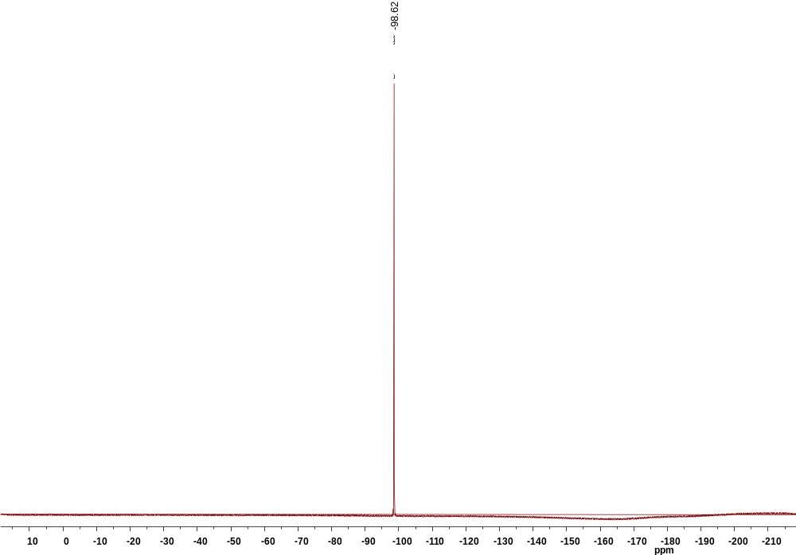
Fig. S21 ¹⁹F NMR of compound 5g
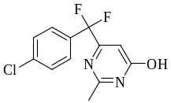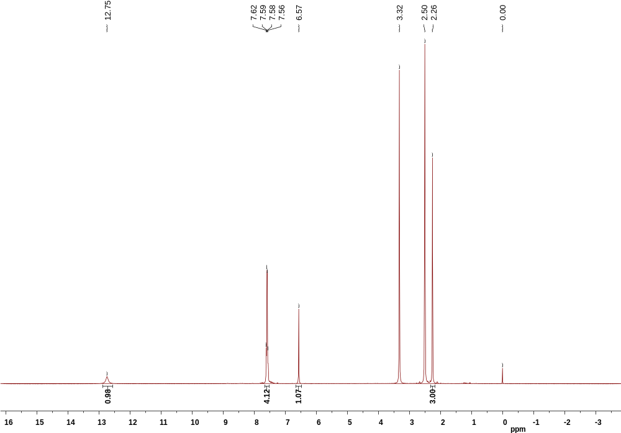
Fig. S22 ¹H NMR of compound 5h

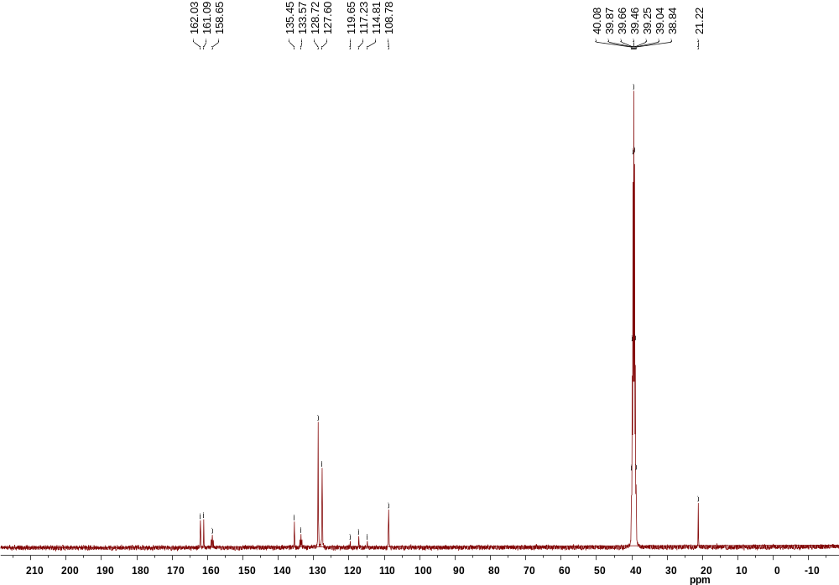
Fig. S23 ¹³C NMR of compound 5h

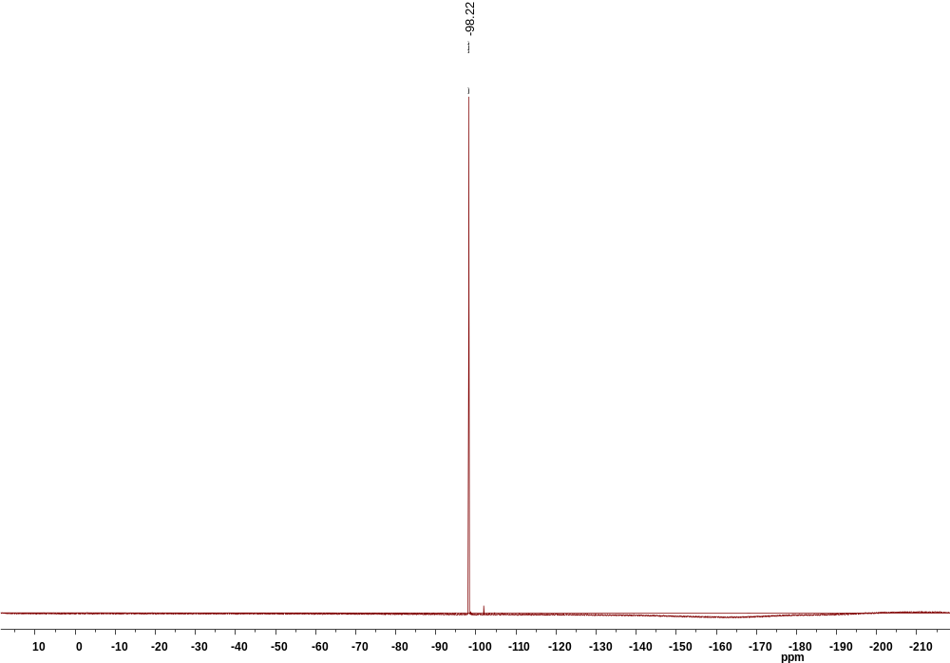
Fig. S24 ¹⁹F NMR of compound 5h

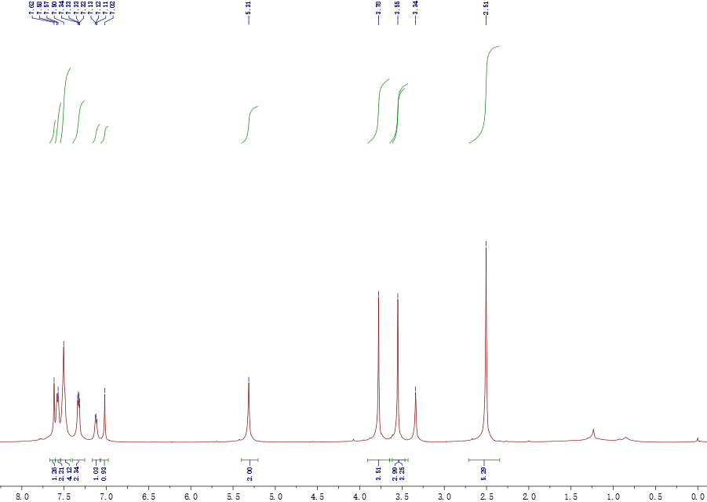
Fig. S25 ¹H NMR of compound 7b

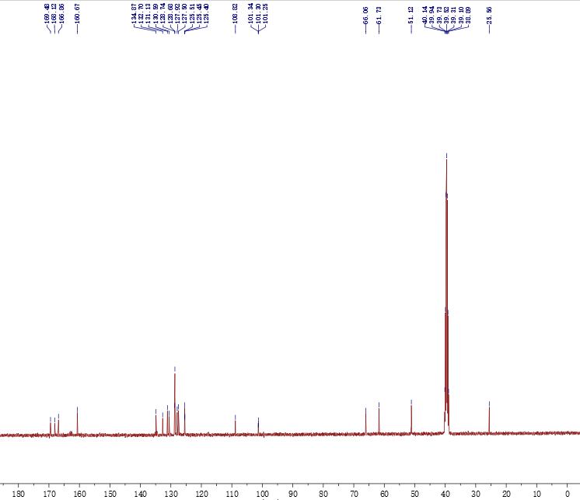
Fig. S26 ¹³C NMR of compound 7b

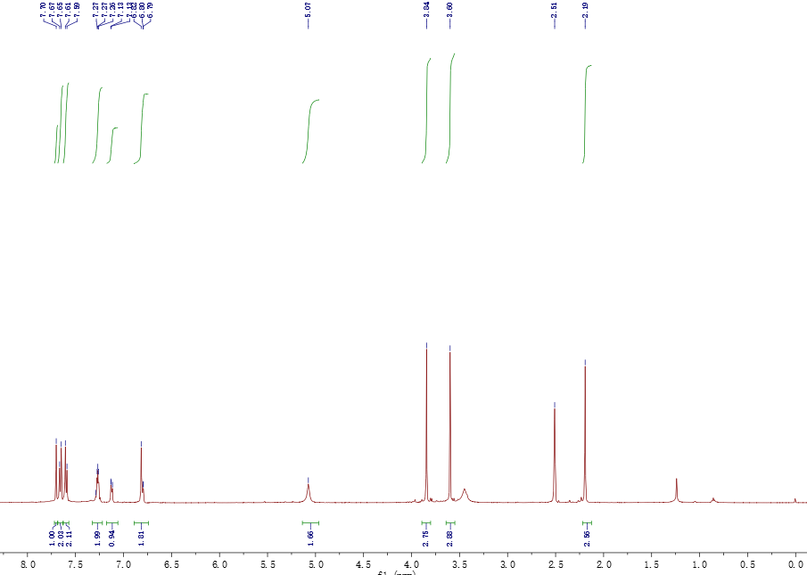
Fig. S27 ¹H NMR of compound 7g

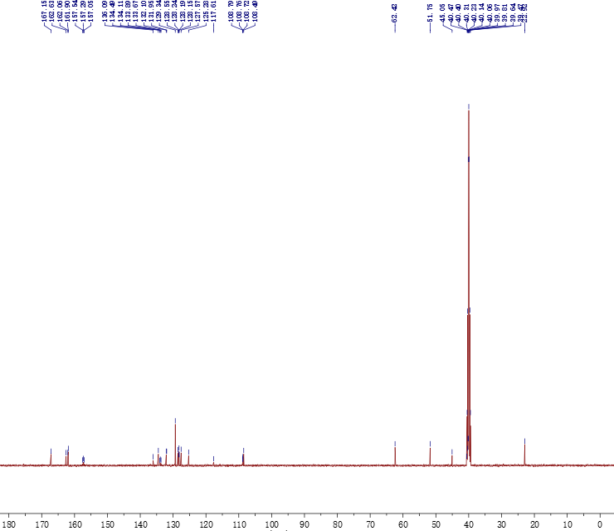
Fig. S28 ¹³C NMR of compound 7g

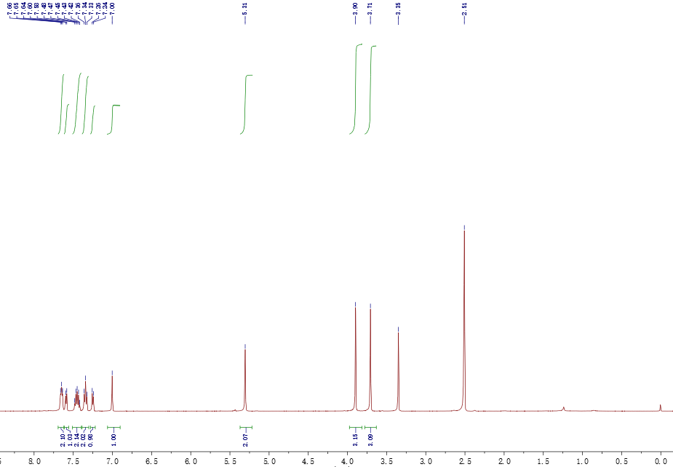
Fig. S29 ¹H NMR of compound 7i

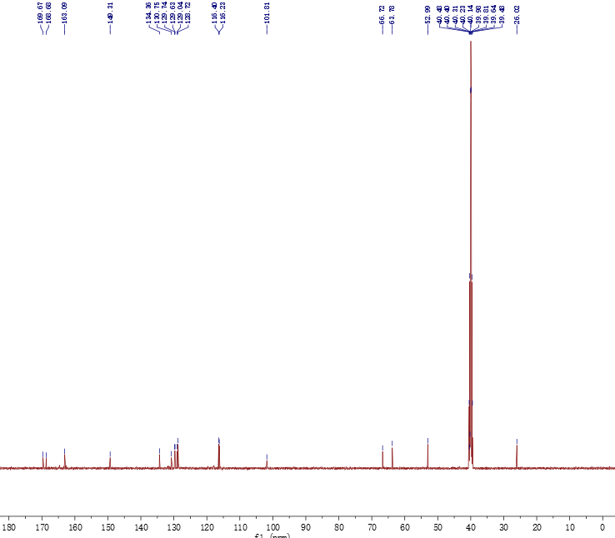
Fig. S30 ¹³C NMR of compound 7i

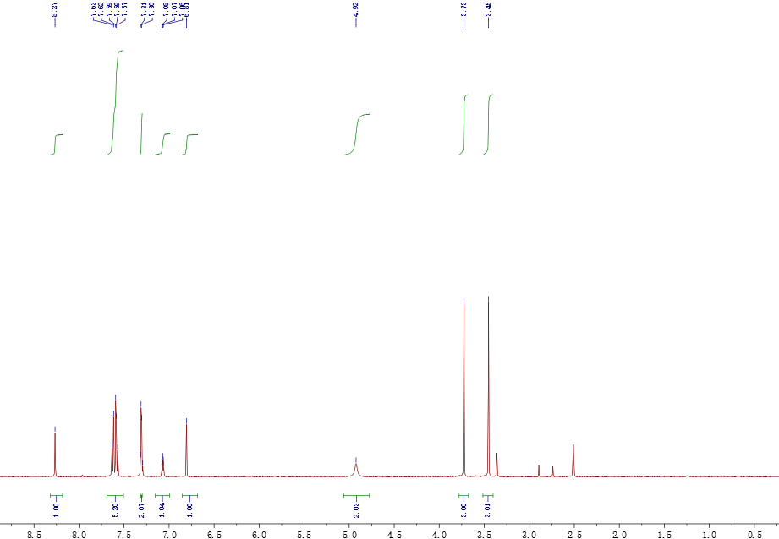
Fig. S31 ¹H NMR of compound 7j

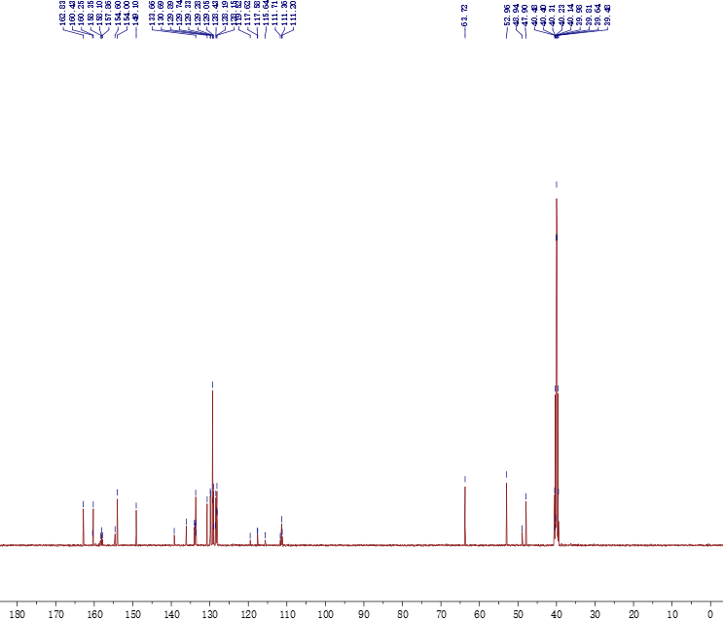
Fig. S32 ¹³C NMR of compound 7j

